Media Kit
Media contact: Martin Keller, Media Savant Communications, mkeller@mediasavantcom.com, 612-220-6515, @mediasavant
My Father Against The Nazis at a Glance
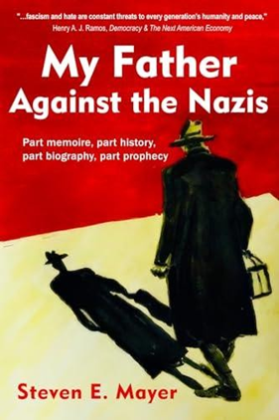
In 1907, a son is born into an assimilating professional Jewish family at a time of rising expectations in Imperial Germany. Recent military victories and the Industrial Revolution have promoted Rhineland Prussia to prominence on the European and world stages.

This son, Paul Mayer, carries the bloodlines of reformers, advocates, warriors, and healers. Unfortunately, this emergence to prominence is not meant for all Germans, even those that faithfully served the values of those who have come before. The embrace of exclusionary Nazi ideology and the fall of Weimar democratic idealism conspire to end the hopes and dreams of this favored son.

In My Father Against the Nazis, Paul Mayer's lifelong battle in pursuit of justice blends history, reflection, and a light foray into prophecy. His son, Steven E. Mayer, has written in this poignant memoir that the fight against fascism and hate is never over. Mayer skillfully weaves personal narrative with historical context to explore questions that resonate powerfully: How do we recognize the warning signs of
authoritarianism? Does one flee, hunker down, or fight back? And what can we usefully learn from history?

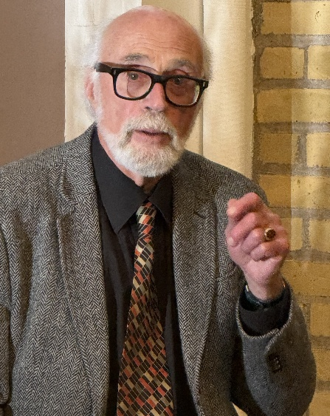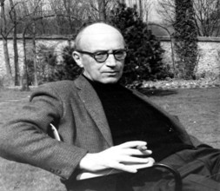
The author (left) and his father, US Army Intelligence “Ritchie Boy” and postwar reparations lawyer

Acclaim for My Father Against The Nazis
Early reviews already praise the book’s deft storytelling that combines personal Mayer family history in Germany and the broader historical narrative that shaped world events in the last century and their impacts yet today in the 21st century.
Here is a sampling of early praise for the book:
- Steven's story sheds new light on old familiar stories. This book also offers some
guidance for me in my own here and now. It's an ongoing struggle to know how to live through our present moment. What should we do, faced with the tests in our own lives? How do we face these choices, these leaders, this situation? Do we leave, do we stay? How do we resist? What we come to know later as history we know now only as life, and it's not easy. This book is testimony to all those
struggles that came before, those defeats and victories. Our situation is not new, but it is ours. -- Ben Kreilkamp, Twin Cities Playwright, Director, Actor

- This beautifully written memoir, with its intimate storytelling and insightful historical reflection, is an urgent call for vigilance, compassion, and the courage to
confront history head-on. – Rabbi Andrue Kahn, Executive Director, The American Council for Judaism

- This extraordinary book is the result of the author's avid pursuit of his father's story--a father he barely knew and admittedly did not care much for. Paul Mayer, the
father, was a young Jewish lawyer at the time of the Nazi incursion in Germany. Paul and his wife escaped, though reluctantly, to America, but he never fully recovered from the eventual news that his own parents had been murdered in Auschwitz. But what struck me most was how alive and complex Mayer feels on the page. He was a man of principle, a “quiet warrior” who never stopped writing passionate anti-fascist pieces in German American newspapers. The book is
briskly written and full of important historical context, yet it is never heavy-handed. Now as history feels dangerously close to repeating itself, this book could not be more important. I highly recommend it—not just as a family story, but as a reminder of what resilience and moral courage look like. – Jean Passanante, Reader

- My Father Against the Nazis is a truly remarkable story told by a son about his
brilliant and courageous father who maintained his humanity and integrity during the reign of Nazi Germany, one of history’s most horrific periods. Steve’s ability to describe and explain political and personal history, to bring it to life, draws
extensively upon the lineages of his father, Paul Mayer, and mother, Margaret
Koch, both of whom came from generations of distinguished and accomplished families of doctors, lawyers, rabbis, intellectuals, and highly successful business owners. His stories include valuable personal, philosophical, historical, political, and prophetic lessons and insights. -- Arthur T. Himmelman, Senior Fellow, Hubert
H. Humphrey Institute, Retired

Interviews, Reviews and Podcasts Featuring Steven E. Mayer and My Father Against The Nazis


Listen to a recent “Write On! Radio” interview broadcast on KFAI-FM, where Dr. Mayer addresses these questions: “Your reading of German history is quite pronounced, especially re the good, bad and ugly. Have you always been a student of history or did it become part of your passion while researching and later writing the book? What do you hope the takeaway is for Jews -- and non-Jews -- in reading this memoir? You say that America 2025 is not Germany 1933. However, do you agree with the many assessments that the current political climate in America parallels those earlier times, and if you do, is this memoir then really a cautionary tale for readers?


On a podcast for TC Jewfolk, Dr. Mayer was asked: “You've written on topics that are more closely linked to your work as a social scientist; do you think that this book skews away from it, or is it a branch of that genre? Your father came to America, became a Ritchie Boy -- one of the Jewish, U.S. Army soldiers who escaped Nazi Germany and Austria -- and became a reparations lawyer. Did his experience escaping the Nazis help steer him to his career? Did the journey of writing this book help you understand your father and what he experienced? Tune in here.”


After the war, when Paul was a U.S. citizen, he was able to help the Jewish cause by becoming part of the intelligence group called “the Ritchie Boys” who helped interrogate Nazi prisoners. This secret U.S. military intelligence unit, composed mostly of Jewish refugees, was trained at Camp Ritchie, Md. Later in life Paul sought justice by working for reparations for Jews who had lost everything under the Third Reich. ”He understood that defeating fascism is not a one-time victory; it is generational work,” Mayer writes of his father. Pioneer Press Review

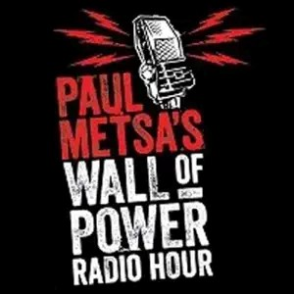
Paul dives into a powerful conversation with legendary folk musician Charlie Maguire and author Steven E. Mayer about the resilience of the human spirit. We’re drawing parallels between the historic 1934 Minneapolis truckers’ strike, the Iron Range labor battles, and the current struggles for justice on our city streets. It’s an episode steeped in local history, family legacy, and the enduring strength of communities standing together in hard times.


Described as “part memory, part history, part biography, part prophecy,” Steven Mayer’s book is his attempt to find some peace with his difficult father…. and is required reading for anyone interested in learning more about the run-up to World War II. Sometimes to tell a big story, you go small, and that’s what Mayer has done, using the experiences of his father and extended family to tell the story of World War II and the Holocaust. –Athens, Georgia, alternative weekly newspaper

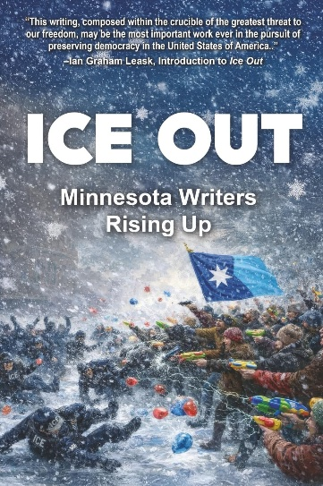
ICE OUT: Minnesota Writers Rising Up is a powerful anthology of poetry and prose responding to the presence of U.S. Immigration and Customs Enforcement (ICE) in Minnesota—and to the human cost of policies that blur the line between law enforcement and occupation. Included in this timely collection is Steven Mayer’s insightful essay, "Is the US becoming like Germany in the 1930s?” Published in collaboration between Afton Press and Calumet Editions, ICE OUT is both a work of literature and an act of resistance. It speaks to readers concerned with immigration justice, civil liberties, contemporary American politics, and the enduring role of writers in times of crisis. This book is for readers who believe that words still matter—and that bearing witness is a form of action.



On this episode of "Life Unscripted", are we repeating a dark time in history? Author Steven E. Mayer shares his family’s fallout with Alix Kendall detailed in his memoir, “My Father Against the Nazis.” The parallels of the ICE operation, and the Gestapo in Nazi Germany, have been sounding the alarm bells to many Holocaust educators, even though it wasn’t Meyer’s original intention in writing the book. The crisis happening in Minneapolis since “Operation Metro Surge” where masked ICE agents have been brutally grabbing people off the streets, has forever changed its people, and likely generations to come. The murders of Renee Good and Alex Pretti have brought worldwide awareness to how the Trump Administration is handling immigration enforcement in the United States. Connecting dots, and generation trauma is what this conversation is all about.

The “Fearsome Wounds of Memory” Explored Through History and Family
Mayer’s fascinating memoir, My Father Against the Nazis, is as engrossing a read about WWII Germany and Mayer’s closest Jewish family members as it is an honest inventory of the "fearsome wounds of memory." The details in the newsreel headlines drawn from national and world events that set up each chapter of the book -- and the more nuanced telling of his family’s story of resistance -- make it a thoughtful, compelling read.
In his diligent and well-researched work, the author explores the following:
- A multi-generational story spanning from the early 1900s through present day.
- Personal family history interwoven with major historical events.
- The lasting impact of trauma and displacement on families.
- Questions about historical cycles and whether lessons are learned.
- A son's long journey to understand his difficult father through history and family archives.
Mayer writes in the book, “The First World War set the template for large-scale conflict that was enlarged in the Second and continues to this day. Paul and his family–all our families, past and present–continue to be caught up in its dynamics,” but Mayer cautions against drawing too many parallels to the far-right movements in the West today and that of WWII Germany:
“I agree there are similarities between then and now. But it is also true that no one knows what tomorrow will bring. Aligning what we all do today to create tomorrow matters. Yes, this memoir is partly a cautionary tale, even though I did not write it to be a prediction of the future. I wrote it as my family’s story – set in yesterday’s circumstances even while there are trajectories that begin to mirror here and now.
“My litany of all the things the Nazis did to chase the Jews out of Germany/Europe, all the things Hitler did to seize the power to enable his mad schemes, serve to inform strategy for our time now. No one has answers of how to change this mess. But I know it takes deliberate action. America has way more resources and talent for resistance than Germany ever did,” Mayer says.

Where Mayer’s book fits among the multitude stories told about Nazis
- My Father Against the Nazis is more than a Holocaust memoir. It is the story of Paul Mayer's lifelong legal battle to reclaim what the Nazis stole, the intergenerational transmission of trauma, and a son's quest to understand his difficult father within the vast currents of 20th-century history.

- A formally innovative memoir that grapples with the challenge of writing about inherited trauma and the 'unwritable.' Mayer's honest portrayal of his difficult relationship with his father, combined with his sophisticated historical consciousness, creates a work that transcends typical Holocaust narratives.
- By tracing the “waves of history” across five generations, Mayer illuminates timeless patterns of how societies slide toward authoritarianism—and how individuals and families respond. Readers seeking to understand our current moment will find not prescriptive parallels, but deeper insights into the recurring dynamics of power, resistance, and survival.
- Also important is the theme of personal reflection and reconciliation and their relation to mental health, growth, dialogue, cooperation, literacy, expression, art/music, trust, peace.

On reparations that his father pursued after the war as a US citizen
Although Steven’s father never saw front-line combat in the war against the Nazis, even though he enlisted in the US Army after Germany declared war on the US, he eventually was able to help the cause by becoming part of an elite intelligence group called “the Ritchie Boys.”

“And after the war, my father sought justice by seeking reparations through the German courts, suing for restitution and recognition,” Mayer notes. “It was a different kind of resistance—methodical, legal, relentless. He understood that defeating fascism is not a one-time victory; it is generational work.”

More About Steven E. Mayer, PhD
Dr. Mayer is the son of this story’s protagonist. He became a consulting psychologist and founded the nonprofit Rainbow Research, Inc, dedicated to helping socially concerned organizations respond more effectively to social problems and opportunities.
His professional insights are also shared in his other book, “How to Save the World: Evaluating Your Choices,” (also available from the same sources as “My Father Against the Nazis,” and on his website, EffectiveCommunities.com
On that same website one can find a longer biography of Dr. Mayer.

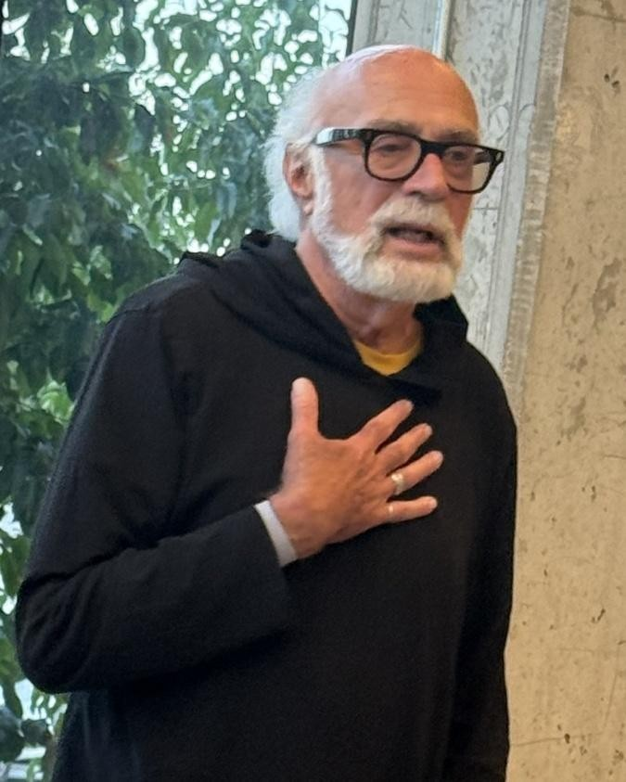
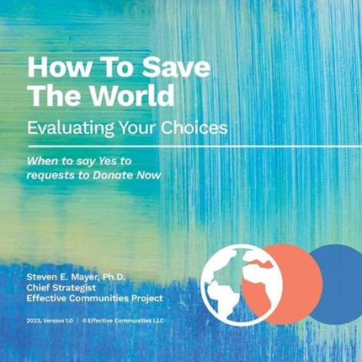
IMMEDIATE RELEASE

Media Notice
ASSETS: Copies of the book (Paperback or PDF), Photos, Interviews

Contact: Martin Keller. Media Savant Communications
612-220-6515, mkeller@medisavantcom.com, @mediasavant

The Book Explores Questions about the Cycles of History Leading to Conflict while Drawing Parallels to the Alarming Similarities Between 1933 Germany and Now

MINNEAPOLIS AUTHOR STEVEN E. MAYER’S NEW MEMOIR – MY FATHER AGAINST THE NAZIS – COMBINES DETAILED HISTORICAL AND MOVING PERSONAL STORYTELLING

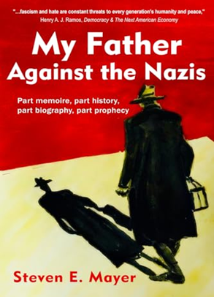
MINNEAPOLIS, MN -- January 2026 – Minneapolis author and organization psychologist, Dr. Steven E. Mayer, PhD, has written a timely new memoir My Father Against the Nazis (see CalumetEditions.com for access to paperback and e-reader options).
Part memoir, part history, part biography, part prophecy, this insightful work is already drawing strong reviews and interest (SEE MEDIA KIT) as it addresses many key themes strongly prevalent today.

Throughout My Father Against the Nazis, Mayer delves into a stimulating range of topics including:

- America’s continued fascination with World War II, especially its role before, during, and after the war against fascism and for democracy.

- The expansive historical 1.000-year history of Europe, especially its progression of colonialism, militarism, globalism, migration, wealth and poverty.

- The intergenerational transmission of trauma among Jews and others as well as of hope and the struggle to create a more viable, just, and resilient world.
This vivid and deeply personal book tells the true story of his father Paul Mayer, a lawyer, born into an upper middle class Jewish family in Cologne. Destined for success, he then endured Nazi persecution and was finally forced to flee after Kristallnacht with his lovely and distinguished wife. He then fought with the U.S. Army's Ritchie Boys intelligence unit against Hitler, and later pursued WWII restitution through the German courts. My Father Against the Nazis is a work of remembrance, resistance, and reconciliation—layered with the author’s own reckoning as the son of a man silenced by trauma but stirred by justice.
Early reviews already praise the book’s deft storytelling that combines personal Mayer family history in Germany and the broader historical narrative that shaped world events in the last century and their impacts yet today in the 21st century.
The author (left) and his father, a WWII US Army Intelligence “Ritchie Boy” and postwar reparations lawyer
More About Steven Mayer’s Memoir
In 1907, a son is born into an assimilating professional Jewish family at a time of rising expectations in Imperial Germany. Recent military victories and the Industrial Revolution have promoted Rhineland Prussia to prominence on the European and world stages. This son, Paul Mayer, carries the bloodlines of reformers, advocates, warriors, and healers. Unfortunately, this emergence to prominence is not meant for all Germans, even those that faithfully served the values of those who have come before. The embrace of exclusionary Nazi ideology and the fall of Weimar democratic idealism conspire to end the hopes and dreams of this favored son.
Steven Mayer begins his storytelling in 1959, when as a sixteen-year-old he performed in The Diary of Anne Frank. He wore his father's long coat made from cellulose from his parent’s 1939 escape from Nazi Germany. The next morning, he asked his parents over breakfast about what really happened; his father’s silent scream revealed depths of trauma that would take decades for the son to process.
So began young Mayer’s journey not just to understand his father’s lifelong angst and the wide chasm between them, but to comprehend the often-incomprehensible history of the last century and its two world wars – a personal trek that took him 40-plus years to unravel and understand. Today, after writing from his second home in Amsterdam, his city of refuge, Mayer has pieced together five generations of his family's haunting and heroic story through recovered documents, legal papers, and travels of discovery into his German heart of darkness. It is a story of intergenerational trauma and love.
The Book Hints at Parallels between Germany in the 1930s and Contemporary America that are Provocative but Not Inevitable

As the resurgence of fascist rhetoric continues to haunt the global stage, Dr. Mayer’s My Father Against the Nazis arrives as a moving and urgent reminder of what happens when hatred goes unchecked—and how one man chose to resist. With chilling relevance to today’s threats to democracy and civil rights, it’s also a story of hope, refusal, and personal courage.

Mayer points out that “we do not live in Germany or in 1933, but in the United States today. Yes, there are similarities, and our times feel dangerous and perilous. Still, there are many possible healing and restorative trajectories for the future, and America has far more going for it than Germany ever did, and I welcome that discussion.”
The Second Edition of Mayer’s memoir, “My Father Against the Nazis” is now available from Amazon, Bookshop.org and other digital platforms, as well as retail booksellers and public libraries.
For more information, a Media Kit is available upon request.

To interview Dr. Mayer about his timely new memoir, My Father Against the Nazis, please contact Martin Keller, Media Savant Communications, 612-220-6515, mkeller@mediasavantcom.com, @mediasavant

